

ROYAL GLOBAL UNIVERSITY

**Paper name**- Open source software

Assignment

Submitted by:-

Name:- Ashadur Rahman Choudhury

Roll No- 202163003

Dept- B.sc Geology

Submitted to:-

Suparna ma’am

Date:- 25-06-2021

1. Calculate the product of two integers. If the product is greater than 1200, then return their sum else return their difference.

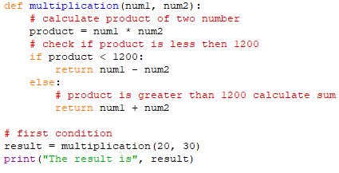

OUTPUT

C:\Users\LENOVO\Pictures\1 output.png

1. Use a list/tuple containing 10 values. Iterate through the values and calculate the sum of the previous value and the current value.

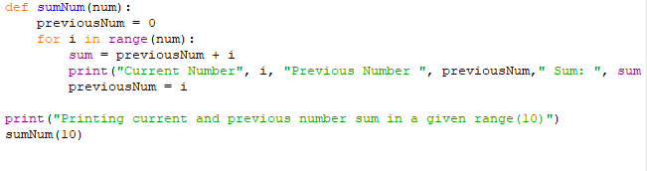

OUTPUT

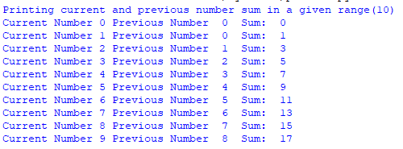

1. Given a string (e.g. “I want to hear from you. What do you think of this basic python exercise.”) count the occurrence of a substring (e.g. “you”) in it.

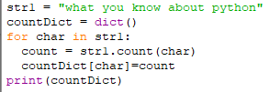

OUTPUT

C:\Users\LENOVO\Pictures\4 output.png

1. Write code to reverse a string. Check if the new string is a palindrome. Next, insert space character (“ “) after every letter in the new string.

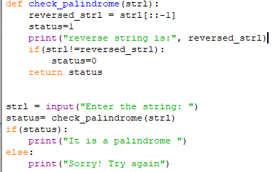

OUTPUT

C:\Users\LENOVO\Pictures\5 output.png